**LETTER FROM THE PRESIDENT**

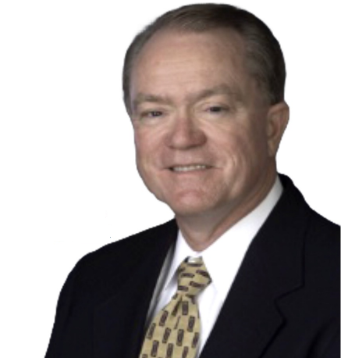

As GBA approaches 50, it truly seems much more like 50-years-young than 50-years-old.

On May 1, 2018, we released our [2020 Strategic Plan](https://3gdfal262dfq3ocgq0gj5624-wpengine.netdna-ssl.com/wp-content/uploads/2018/04/2018-20120-Strategic-Planning-Flyer.pdf) to promote our rich history and prepare for the next 50 years. As President, during the fiscal year, I will help set the stage for our 50th year, which begins May 1, 2019, and build a foundation to execute on the 2020 Strategic Plan through the three strategic initiatives identified by the Board.



With an almost 50 years of history, “GBA” is an evolving brand, one that needs our continued efforts to promote and strengthen. To that end, the first of our new 2020 strategic initiatives is to **Strengthen our Brand**. As we celebrate the ASFE legacy that has provided us with a strong foundation to build upon, we must harness the inertia of our history and focus to strengthen the GBA brand as **the essential business resource for geoprofessional firms.**

ASFE began as an organization to help member firms confront the growing risks of our “geoprofession.” But realizing that the risks to individuals and member firms extend well beyond our technical practice, GBA has broadened its scope to help both individuals and our Member Firms optimize their performance. Our members freely share their collective talent, energy, expertise, and experience to provide extensive business resources – the GBA “Right Stuff” – and acclaimed programs in an environment of trust, all to help one another succeed as firms and individuals.



As GBA begins its next 50 years, the second of our new strategic initiatives is to **Turbocharge the Member Experience**. “Turbocharge” means doing things faster and better. To be ***the*** essential business resource for geoprofessional firms and to provide a truly unique “member experience” to further drive value and connection, we must develop and produce the most-effective and most-impactful resources first and faster. We have a reputation of “getting stuff done.” Let’s turbocharge that reputation. Let’s get GBA’s “Right Stuff” re-branded, faster. Turbocharging also means adding energy through the infusion of diversity, diversity of thought and ideas.

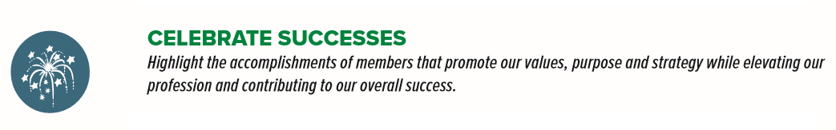

The late business author Stephen Covey suggests, “The deepest desire of the human spirit is to be acknowledged.” The third of our new strategic initiatives is to **Celebrate Our Successes** by acknowledging the contributions of our volunteers and volunteer leaders to GBA’s success. Beyond the planned activities and recognitions of our anniversary, we must continue to celebrate the efforts of our members and member firms as they contribute to GBA’s overall success by promoting the GBA values, purpose, and strategy while advancing and elevating the geoprofessions.

To our members, thank you for your support and collegiality, and for your contributions to help make GBA strong and vital.  If you are a member and not yet immersed in the GBA experience, I encourage you to attend one of our conferences and consider active participation through one of our [Committees or Councils](https://www.geoprofessional.org/join-a-committeecouncil/); I believe you will find your efforts rewarding.  If you are not yet a member, I invite and encourage you to consider [joining us](https://www.geoprofessional.org/why-join-gba-gba-member-firm-benefits/) as we begin our next 50 years.

Thank you.

Woodward L. “Woody” Vogt, P.E., D.GE

GBA President 2018-19